import pandas as pd

import numpy as np

import matplotlib.pyplot as plt

**# read the data set**

dataset = pd.read_csv("general_data.csv")

dataset.head()

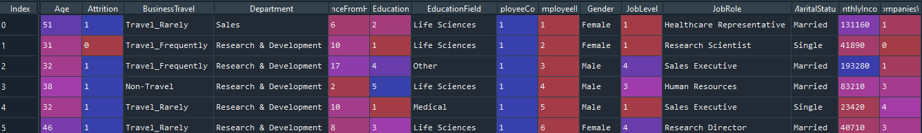

dataset['Attrition'].replace({'Yes':0,'No':1},inplace=True)

**Wilcoxon test**

# Ho = There is no significant difference NumCompaniesWorked and Attrition

# H1 = There is significant difference NumCompaniesWorked and Attrition

from scipy.stats import wilcoxon

stats,p = wilcoxon(dataset.Attrition,dataset.NumCompaniesWorked)

print(stats,p)



If **p<0.05**  so we reject H0

**Friedman chi square Test**

# Ho = There is no significant difference NumCompaniesWorked and Attrition and Years Since Last Promotion

# Ha = There is significant difference NumCompaniesWorked and Attrition and Years Since Last Promotion

from scipy.stats import friedmanchisquare

p,stats = friedmanchisquare(dataset.YearsSinceLastPromotion,dataset.Attrition,dataset.NumCompaniesWorked)

print(stats,p)



If **P>0.05**  so we accept HO

**Mann whitney Test**

# Ho = There is no significant difference Attrition and JobLevel

# Ha = There is significant difference Attrition and Job Level

from scipy.stats import mannwhitneyu

stat,p=mannwhitneyu(dataset.Attrition,dataset.JobLevel )

print(stat,p)



If P<0.05 so we reject HO